1. Give two example computer applications for which connection-oriented (through virtual circuits) service is appropriate. Now give two examples for which connectionless (through datagram networks) service is best.

Virtual Circuits:

* Microsoft Teams
* Google Meets

Video conferencing software where people need to hear and/or see people without any issues such as staticky audio or latency to have effective communication with each other.

Connectionless:

* G-Mail
* Messenger

Messaging software where users can send files / attachments to each other.

2. Give three examples of protocol parameters that might be negotiated when a connection is set up.

* Time to Life – Determine the max number of hops that packet could take before being discarded
* Network admin can specify router(s) that packet must travel to.
* Network admin can also have the packets time stamp when they arrived at that specific router.

3. Assume that all routers and hosts are working properly and that all software in both is free of all errors, is there any chance, however small, that a packet will be delivered to the wrong destination?

A packet can be delivered to the wrong destination. This may occur if the packet is corrupted but still does not violate the checksum in it’s header when the destination node checks it.

4. Convert the IP address whose hexadecimal representation is C22F1582 to dotted decimal notation.

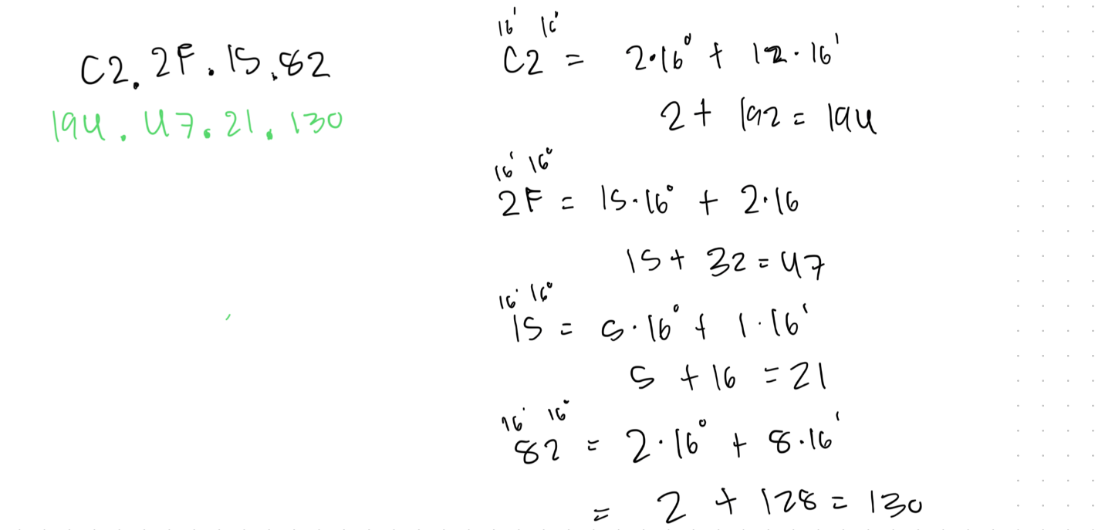

5. A network on the Internet has a subnet mask of 255.255.240.0. What is the maximum number of hosts it can handle?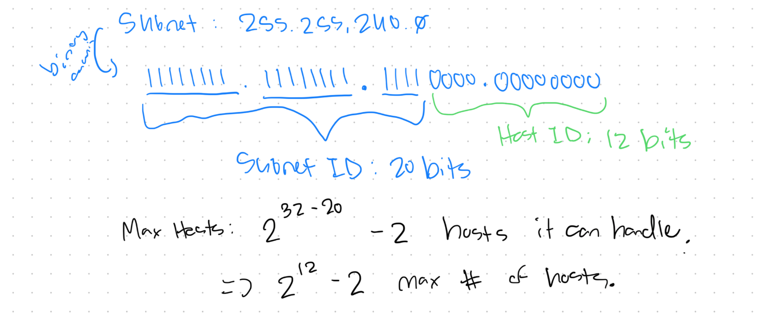

6. A large number of consecutive IP addresses are available starting at 198.16.0.0. Suppose that four organizations, A, B, C, and D, request 4000, 2000, 4000, and 8000 addresses, respectively, and in that order. For each of those, give the first IP address assigned, the last IP address assigned, and the mask in the w.x.y.z/s notation.

